Департамент образования и науки города Москвы

Государственное автономное образовательное учреждение

высшего образования города Москвы

«Московский городской педагогический университет»

Институт цифрового образования

Департамент информатики управления и технологий

Агафонов Антон Александрович БД-241м

## **Практическая работа 2. Изучение методов хранения данных на основе NoSQL MongoDB**

Направление подготовки/специальность

38.04.05 - Бизнес-информатика

Бизнес-аналитика и большие данные

(очная форма обучения)

ФИО преподавателя

Босенко Тимур Муртазович

Вариант 1

Москва

2025

Цель работы: получить практические навыки работы с документо-ориентированной базой данных MongoDB путем выполнения основных операций по управлению данными.

Ход работы

Подключаемся к среде mongodb

**Sudo docker compose start**

**Sudo docker exec -ti mongo-1 mongosh -u “root” – p “abc123!”**



Рис.1 запуск mongodb

Создаем базу данных filmb в mongoexpress

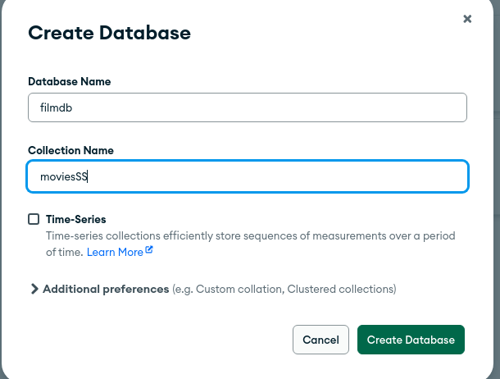

Рис.2 создание базы данных

Рис.3 создание базы данных

Создаем документ

{

"id": "0110912",

"title": "Pulp Fiction",

"year": 1994,

"runtime": 154,

"languages": ["en", "es", "fr"],

"rating": 8.9,

"votes": 2084331,

"genres": ["Crime", "Drama"],

"plotOutline": "Jules Winnfield (Samuel L. Jackson) and Vincent Vega (John Travolta) are two hit men who are out to retrieve a suitcase stolen from their employer, mob boss Marsellus Wallace (Ving Rhames). Wallace has also asked Vincent to take his wife Mia (Uma Thurman) out a few days later when Wallace himself will be out of town. Butch Coolidge (Bruce Willis) is an aging boxer who is paid by Wallace to lose his fight. The lives of these seemingly unrelated people are woven together comprising of a series of funny, bizarre and uncalled-for incidents.",

"coverUrl": "https://m.media-amazon.com/images/M/MV5BNGNhMDIzZTUtNTBlZi00MTRlLWFjM2ItYzViMjE3YzI5MjljXkEyXkFqcGdeQXVyNzkwMjQ5NzM@._V1_SY150_CR1,0,101,150_.jpg",

"actors": [

{ "actorID": "0000619", "name": "Tim Roth"},

{ "actorID": "0001625", "name": "Amanda Plummer"},

{ "actorID": "0522503", "name": "Laura Lovelace"},

{ "actorID": "0000237", "name": "John Travolta"},

{ "actorID": "0000168", "name": "Samuel L. Jackson"},

{ "actorID": "0482851", "name": "Phil LaMarr"},

{ "actorID": "0001844", "name": "Frank Whaley"},

{ "actorID": "0824882", "name": "Burr Steers"},

{ "actorID": "0000246", "name": "Bruce Willis"},

{ "actorID": "0000609", "name": "Ving Rahmes"},

{ "actorID": "0000235", "name": "Uma Thurman"},

{ "actorID": "0000233", "name": "Quentin Tarantino"}

],

"directors": [

{ "directorID": "0000233", "name": "Quentin Tarantino"}

],

"producers": [

{ "producerID": "0004744", "name": "Lawrence Bender"},

{ "producerID": "0000362", "name": "Danny DeVito"},

{ "producerID": "0321621", "name": "Richard N. Gladstein"},

{ "producerID": "0787834", "name": "Michael Shamberg"},

{ "producerID": "0792049", "name": "Stacey Sher"},

{ "producerID": "0918424", "name": "Bob Weinstein"},

{ "producerID": "0005544", "name": "Harvey Weinstein"}

]

}

Рис.4 создание документа



Рис.5 создание документа

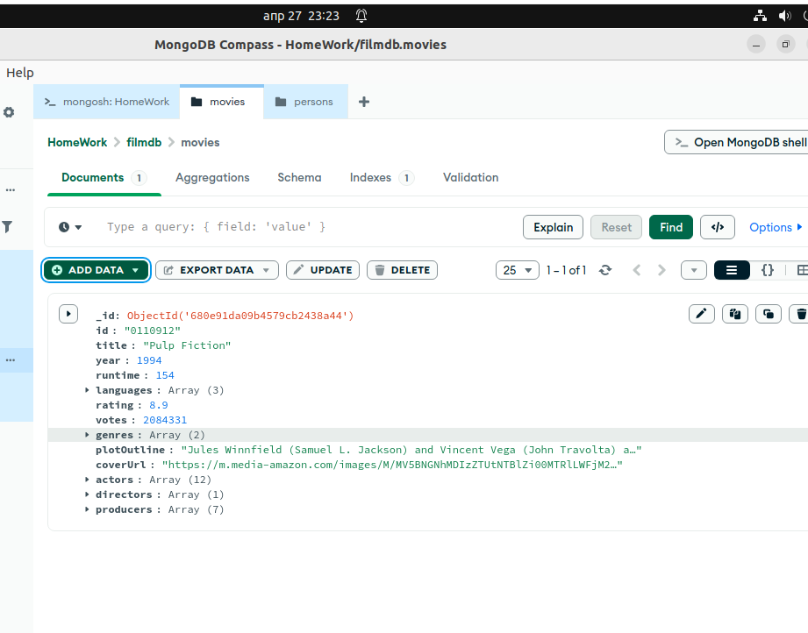

Рис.6 результат созданного документа

Поиск вставленного документа

**db.movies.findOne({ "title": "Pulp Fiction" })**

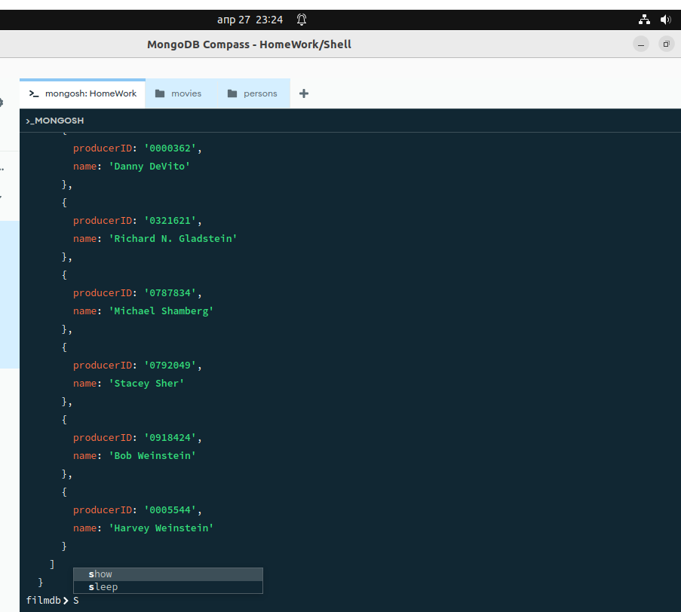

Рис.7 Поиск вставленного документа

Добавляем фильм Матрица в базу данных

**db.movies.insertOne(**

**{**

**"id": "0133093",**

**"title": "The Matrix",**

**"year": 1999,**

**"runtime": 136,**

**"languages": ["en"],**

**"rating": 8.7,**

**"votes": 1496538,**

**"genres": ["Action", "Sci-Fi"],**

**"plotOutline": "Thomas A. Anderson is a man living two lives. By day he is an average computer programmer and by night a hacker known as Neo. Neo has always questioned his reality, but the truth is far beyond his imagination. Neo finds himself targeted by the police when he is contacted by Morpheus, a legendary computer hacker branded a terrorist by the government. Morpheus awakens Neo to the real world, a ravaged wasteland where most of humanity have been captured by a race of machines that live off of the humans' body heat and electrochemical energy and who imprison their minds within an artificial reality known as the Matrix. As a rebel against the machines, Neo must return to the Matrix and confront the agents: super-powerful computer programs devoted to snuffing out Neo and the entire human rebellion.",**

**"coverUrl": "https://m.media-amazon.com/images/M/MV5BNzQzOTk3OTAtNDQ0Zi00ZTVkLWI0MTEtMDllZjNkYzNjNTc4L2ltYWdlXkEyXkFqcGdeQXVyNjU0OTQ0OTY@._V1_SX101_CR0,0,101,150_.jpg",**

**"actors": [**

**{ "actorID": "0000206", "name": "Keanu Reeves"},**

**{ "actorID": "0000401", "name": "Laurence Fishburne"},**

**{ "actorID": "0005251", "name": "Carrie-Anne Moss"},**

**{ "actorID": "0915989", "name": "Hugo Weaving"},**

**{ "actorID": "0287825", "name": "Gloria Foster"},**

**{ "actorID": "0001592", "name": "Joe Pantoliano"},**

**{ "actorID": "0159059", "name": "Marcus Chong"},**

**{ "actorID": "0032810", "name": "Julian Arahanga"},**

**{ "actorID": "0000246", "name": "Bruce Willis"},**

**{ "actorID": "0000609", "name": "Ving Rahmes"},**

**{ "actorID": "0000235", "name": "Uma Thurman"},**

**{ "actorID": "0000233", "name": "Quentin Tarantino"}**

**],**

**"directors": [**

**{ "directorID": "0905154", "name": "Lana Wachowski"},**

**{ "directorID": "0905152", "name": "Lilly Wachowski"}**

**],**

**"producers": [**

**{ "producerID": "0075732", "name": "Bruce Berman"},**

**{ "producerID": "0185621", "name": "Dan Cracchiolo"},**

**{ "producerID": "0400492", "name": "Carol Hughes"}**

**]**

**})**

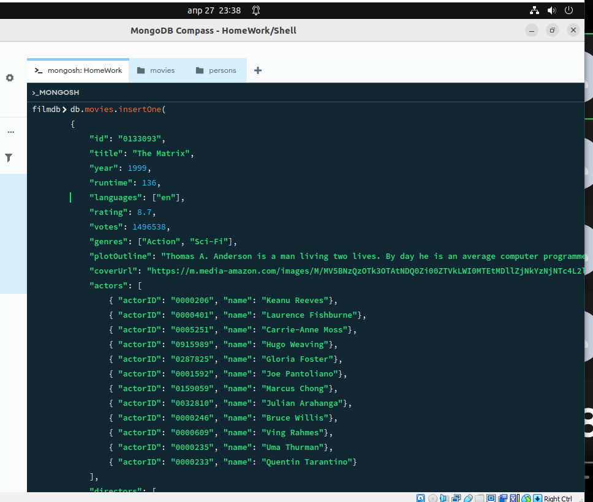

Рис.8 Добавление фильма матрица

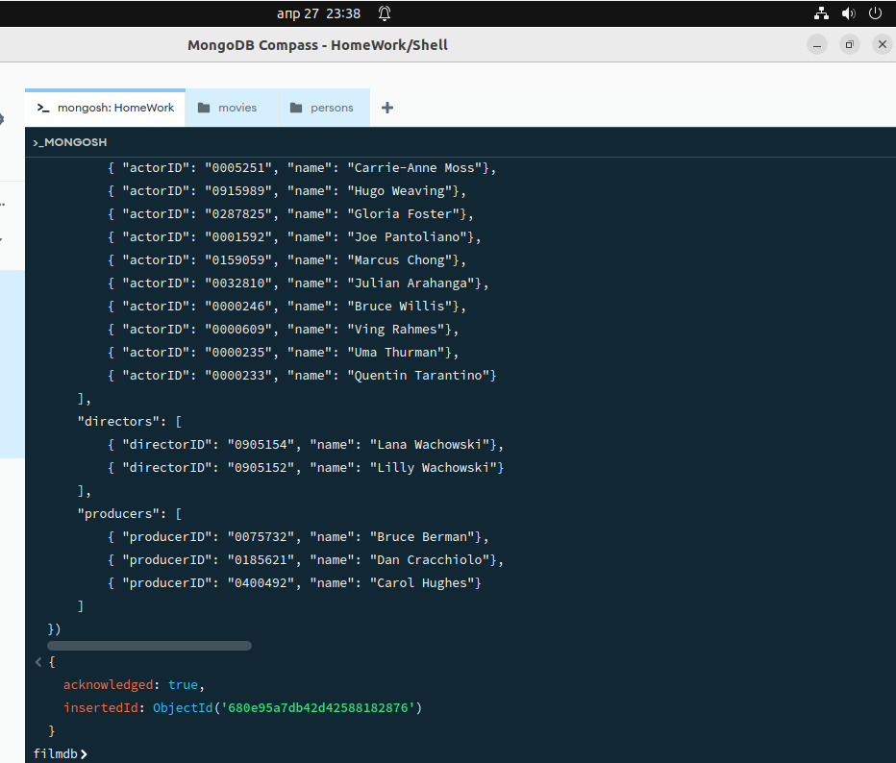

Рис.9 Добавление фильма матрица

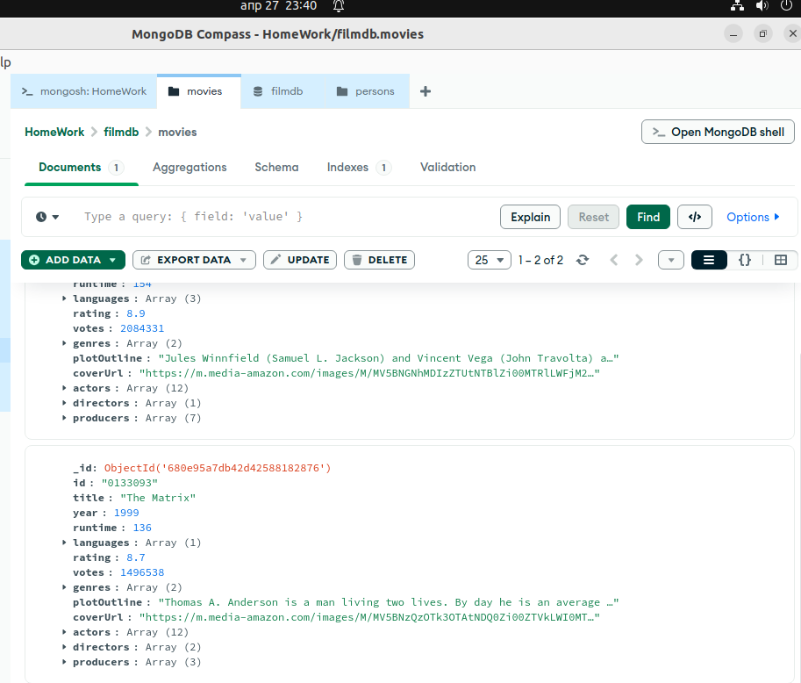

Рис.10 Результат добавления фильма матрица

Создали коллекцию persons, в которую добавили данные актеров

**db.persons.insertOne (**

**{**

**"id": 0000246,**

**"name": "Bruce Willis",**

**"headshot": "https://m.media-amazon.com/images/M/MV5BMjA0MjMzMTE5OF5BMl5BanBnXkFtZTcwMzQ2ODE3Mw@@._V1_UY98_CR8,0,67,98_AL_.jpg",**

**"birthDate": "1955-03-19",**

**"tradeMarks": ['Frequently plays a man who suffered a tragedy, had lost something or had a crisis of confidence or conscience.',**

**'Frequently plays likeable wisecracking heroes with a moral centre',**

**'Headlines action-adventures, often playing a policeman, hitman or someone in the military',**

**'Often plays men who get caught up in situations far beyond their control',**

**'Sardonic one-liners',**

**'Shaven head',**

**'Distinctive, gravelly voice',**

**'Smirky grin.',**

**'Known for playing cynical anti-heroes with unhappy personal lives'],**

**"actedInMovies": [**

**{ "movieId": "0110912", "title": "Pulp Fiction"},**

**{ "movieId": "1606378", "title": "A Good Day to Die Hard"},**

**{ "movieId": "0217869", "title": "Unbreakable"},**

**{ "movieId": "0377917", "title": "The Fifth Element"},**

**{ "movieId": "0112864", "title": "Die Hard: With a Vengeance"}**

**]**

**})**

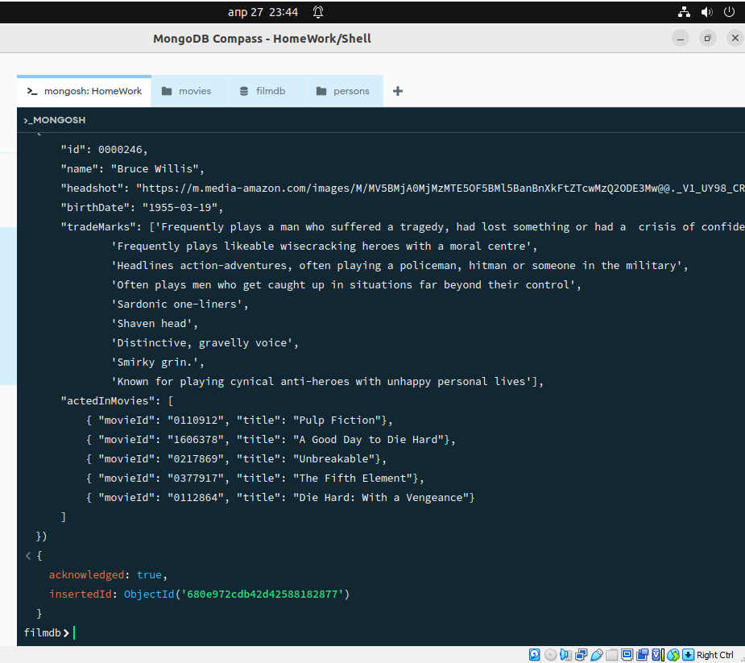

Рис.11 Добавление информации о Брюсе Вилисе



Рис.12 Добавление информации о Брюсе Вилисе

Добавили информацию об Киану Ривз

**db.persons.insertOne (**

**{**

**"id": 0000206,**

**"name": "Keanu Reeves",**

**"headshot": "https://m.media-amazon.com/images/M/MV5BMjA0MjMzMTE5OF5BMl5BanBnXkFtZTcwMzQ2ODE3Mw@@._V1_UY98_CR8,0,67,98_AL_.jpg",**

**"birthDate": "1955-03-19",**

**"tradeMarks": ['Intense contemplative gaze',**

**'Deep husky voice',**

**'Known for playing stoic reserved characters'],**

**"actedInMovies": [**

**{ "movieId": "0133093", "title": "The Matrix"},**

**{ "movieId": "0234215", "title": "The Matrix Reloaded"},**

**{ "movieId": "0111257", "title": "Speed"}**

**]**

**})**



Рис.13 Добавление информации о Киану Ривз

Добавили информацию о Сандре Булок

**db.persons.insertOne (**

**{**

**"id": 0000113,**

**"name": "Sandra Bullock",**

**"headshot": "https://m.media-amazon.com/images/M/MV5BMTI5NDY5NjU3NF5BMl5BanBnXkFtZTcwMzQ0MTMyMw@@._V1_UX67_CR0,0,67,98_AL_.jpg",**

**"birthDate": "1964-07-26",**

**"actedInMovies": [**

**{ "movieId": "2737304", "title": "Bird Box"},**

**{ "movieId": "0120179", "title": "Speed 2: Cruise Control"},**

**{ "movieId": "0111257", "title": "Speed"},**

**{ "movieId": "0212346", "title": "Miss Congeniality"}**

**]**

**})**

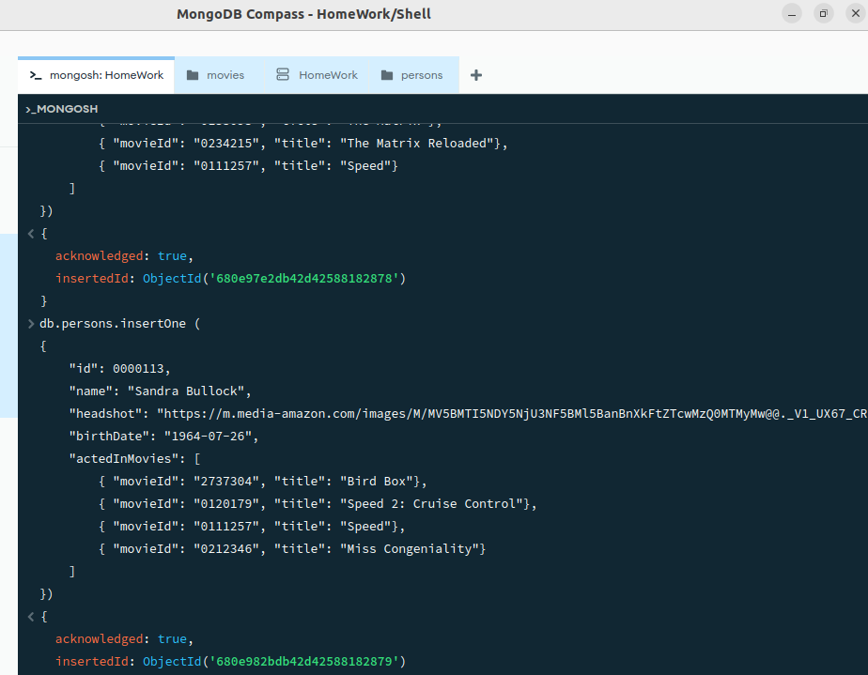

Рис.14 Добавление актеров

Добавили информацию о Квентине Тарантино

**db.persons.insertOne (**

**{**

**"id": 0000233,**

**"name": "Quentin Tarantino",**

**"headshot": "https://m.media-amazon.com/images/M/MV5BMTgyMjI3ODA3Nl5BMl5BanBnXkFtZTcwNzY2MDYxOQ@@._V1_UX67_CR0,0,67,98_AL_.jpg",**

**"birthDate": "1963-03-27",**

**"tradeMarks": ['Lead characters usually drive General Motors vehicles, particularly Chevrolet and Cadillac, such as Jules 1974 Nova and Vincents 1960s Malibu.',**

**'Briefcases and suitcases play an important role in Pulp Fiction (1994), Reservoir Dogs (1992), Jackie Brown (1997), True Romance (1993) and Kill Bill: Vol. 2 (2004).',**

**'Makes references to cult movies and television',**

**'Frequently works with Harvey Keitel, Tim Roth, Michael Madsen, Uma Thurman, Michael Bowen, Samuel L. Jackson, Michael Parks and Christoph Waltz.',**

**'His films usually have a shot from inside an automobile trunk',**

**'He always has a Dutch element in his films: The opening tune, Little Green Bag, in Reservoir Dogs (1992) was performed by George Baker Selection and written by Jan Gerbrand Visser and Benjamino Bouwens who are all Dutch. The character Freddy Newandyke, played by Tim Roth is a direct translation to a typical Dutch last name, Nieuwendijk. The code name of Tim Roth is Mr. Orange, the royal color of Holland and the last name of the royal family. The Amsterdam conversation in Pulp Fiction (1994), Vincent Vega smokes from a Dutch tobacco shag (Drum), the mentioning of Rutger Hauer in Jackie Brown (1997), the brides name is Beatrix, the name of the Royal Dutch Queen.',**

**'[The Mexican Standoff] All his movies (including True Romance (1993), which he only wrote and did not direct) feature a scene in which three or more characters are pointing guns at each other at the same time.',**

**'Often uses an unconventional storytelling device in his films, such as retrospect (Reservoir Dogs (1992)), non-linear (Pulp Fiction (1994)), or "chapter" format (Kill Bill: Vol. 1 (2003)).',**

**'His films will often include one long, unbroken take where a character is followed around somewhere.'],**

**"actedInMovies": [**

**{ "movieId": "0378194", "title": "Kill Bill: Vol. 2"},**

**{ "movieId": "0110912", "title": "Speed 2: Cruise Control"},**

**{ "movieId": "0116367", "title": "From Dusk Till Dawn"},**

**{ "movieId": "0119396", "title": "Jackie Brown"}**

**]**

**})**

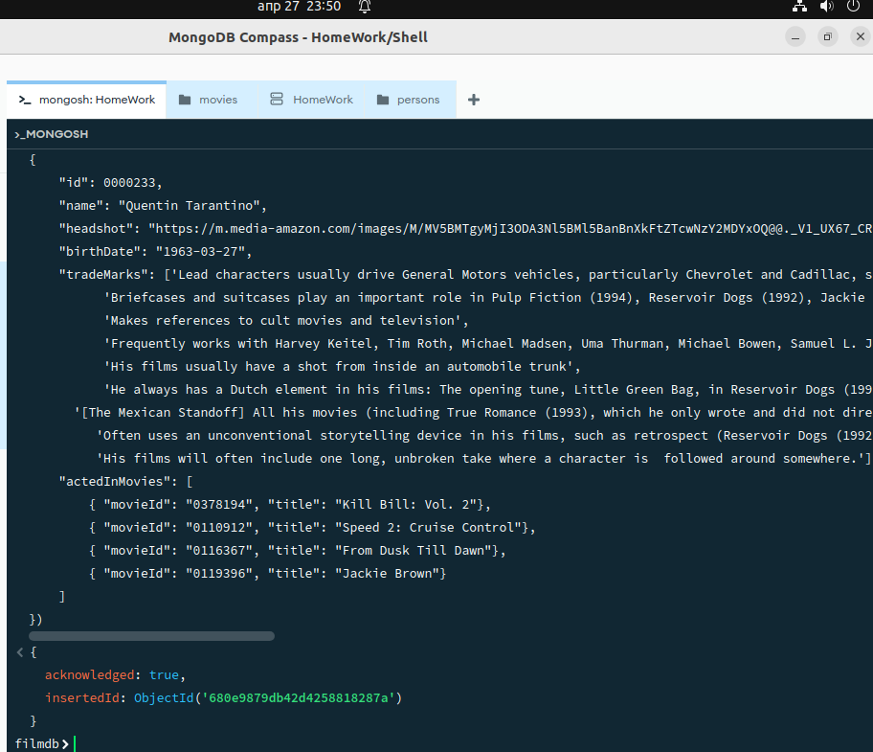

Рис.14 Добавление актеров

Добавили еще 50 фильмов

**db.movies.insertMany([**

**{"id": "0111161", "title": "The Shawshank Redemption", "genres": ["Drama"], "year": 1994, "rating": 9.2, "rank": 1},**

**{"id": "0068646", "title": "The Godfather", "genres": ["Crime", "Drama"], "year": 1972, "rating": 9.2, "rank": 2},**

**{"id": "0071562", "title": "The Godfather: Part II", "genres": ["Crime", "Drama"], "year": 1974, "rating": 9.0, "rank": 3},**

**{"id": "0468569", "title": "The Dark Knight", "genres": ["Action", "Crime", "Drama", "Thriller"], "year": 2008, "rating": 9.0, "rank": 4},**

**{"id": "0050083", "title": "12 Angry Men", "genres": ["Drama"], "year": 1957, "rating": 8.9, "rank": 5},**

**{"id": "0108052", "title": "Schindler's List", "genres": ["Biography", "Drama", "History"], "year": 1993, "rating": 8.9, "rank": 6},**

**{"id": "0167260", "title": "The Lord of the Rings: The Return of the King", "genres": ["Adventure", "Drama", "Fantasy"], "year": 2003, "rating": 8.9, "rank": 7},**

**{"id": "0060196", "title": "The Good, the Bad and the Ugly", "genres": ["Western"], "year": 1966, "rating": 8.8, "rank": 9},**

**{"id": "0137523", "title": "Fight Club", "genres": ["Drama"], "year": 1999, "rating": 8.8, "rank": 10},**

**{"id": "4154796", "title": "Avengers: Endgame", "genres": ["Action", "Adventure", "Fantasy", "Sci-Fi"], "year": 2019, "rating": 8.8, "rank": 11},**

**{"id": "0120737", "title": "The Lord of the Rings: The Fellowship of the Ring", "genres": ["Adventure", "Drama", "Fantasy"], "year": 2001, "rating": 8.8, "rank": 12},**

**{"id": "0109830", "title": "Forrest Gump", "genres": ["Drama", "Romance"], "year": 1994, "rating": 8.7, "rank": 13},**

**{"id": "0080684", "title": "Star Wars: Episode V - The Empire Strikes Back", "genres": ["Action", "Adventure", "Fantasy", "Sci-Fi"], "year": 1980, "rating": 8.7, "rank": 14},**

**{"id": "1375666", "title": "Inception", "genres": ["Action", "Adventure", "Sci-Fi", "Thriller"], "year": 2010, "rating": 8.7, "rank": 15},**

**{"id": "0167261", "title": "The Lord of the Rings: The Two Towers", "genres": ["Adventure", "Drama", "Fantasy"], "year": 2002, "rating": 8.7, "rank": 16},**

**{"id": "0073486", "title": "One Flew Over the Cuckoo's Nest", "genres": ["Drama"], "year": 1975, "rating": 8.7, "rank": 17},**

**{"id": "0099685", "title": "Goodfellas", "genres": ["Biography", "Crime", "Drama"], "year": 1990, "rating": 8.7, "rank": 18},**

**{"id": "0047478", "title": "Seven Samurai", "genres": ["Adventure", "Drama"], "year": 1954, "rating": 8.6, "rank": 20},**

**{"id": "0114369", "title": "Se7en", "genres": ["Crime", "Drama", "Mystery", "Thriller"], "year": 1995, "rating": 8.6, "rank": 21},**

**{"id": "0317248", "title": "City of God", "genres": ["Crime", "Drama"], "year": 2002, "rating": 8.6, "rank": 22},**

**{"id": "0076759", "title": "Star Wars: Episode IV - A New Hope", "genres": ["Action", "Adventure", "Fantasy", "Sci-Fi"], "year": 1977, "rating": 8.6, "rank": 23},**

**{"id": "0102926", "title": "The Silence of the Lambs", "genres": ["Crime", "Drama", "Thriller"], "year": 1991, "rating": 8.6, "rank": 24},**

**{"id": "0038650", "title": "It's a Wonderful Life", "genres": ["Drama", "Family", "Fantasy"], "year": 1946, "rating": 8.6, "rank": 25},**

**{"id": "0118799", "title": "Life Is Beautiful", "genres": ["Comedy", "Drama", "Romance", "War"], "year": 1997, "rating": 8.6, "rank": 26},**

**{"id": "0245429", "title": "Spirited Away", "genres": ["Animation", "Adventure", "Family", "Fantasy", "Mystery"], "year": 2001, "rating": 8.5, "rank": 27},**

**{"id": "0120815", "title": "Saving Private Ryan", "genres": ["Drama", "War"], "year": 1998, "rating": 8.5, "rank": 28},**

**{"id": "0114814", "title": "The Usual Suspects", "genres": ["Crime", "Mystery", "Thriller"], "year": 1995, "rating": 8.5, "rank": 29},**

**{"id": "0110413", "title": "L\u00e9on: The Professional", "genres": ["Action", "Crime", "Drama", "Thriller"], "year": 1994, "rating": 8.5, "rank": 30},**

**{"id": "0120689", "title": "The Green Mile", "genres": ["Crime", "Drama", "Fantasy", "Mystery"], "year": 1999, "rating": 8.5, "rank": 31},**

**{"id": "0816692", "title": "Interstellar", "genres": ["Adventure", "Drama", "Sci-Fi"], "year": 2014, "rating": 8.5, "rank": 32},**

**{"id": "0054215", "title": "Psycho", "genres": ["Horror", "Mystery", "Thriller"], "year": 1960, "rating": 8.5, "rank": 33},**

**{"id": "0120586", "title": "American History X", "genres": ["Drama"], "year": 1998, "rating": 8.5, "rank": 34},**

**{"id": "0021749", "title": "City Lights", "genres": ["Comedy", "Drama", "Romance"], "year": 1931, "rating": 8.5, "rank": 35},**

**{"id": "0034583", "title": "Casablanca", "genres": ["Drama", "Romance", "War"], "year": 1942, "rating": 8.5, "rank": 36},**

**{"id": "0064116", "title": "Once Upon a Time in the West", "genres": ["Western"], "year": 1968, "rating": 8.5, "rank": 37},**

**{"id": "0253474", "title": "The Pianist", "genres": ["Biography", "Drama", "Music", "War"], "year": 2002, "rating": 8.5, "rank": 38},**

**{"id": "0027977", "title": "Modern Times", "genres": ["Comedy", "Drama", "Family", "Romance"], "year": 1936, "rating": 8.5, "rank": 39},**

**{"id": "1675434", "title": "The Intouchables", "genres": ["Biography", "Comedy", "Drama"], "year": 2011, "rating": 8.5, "rank": 40},**

**{"id": "0407887", "title": "The Departed", "genres": ["Crime", "Drama", "Thriller"], "year": 2006, "rating": 8.5, "rank": 41},**

**{"id": "0088763", "title": "Back to the Future", "genres": ["Adventure", "Comedy", "Sci-Fi"], "year": 1985, "rating": 8.5, "rank": 42},**

**{"id": "0103064", "title": "Terminator 2: Judgment Day", "genres": ["Action", "Sci-Fi"], "year": 1991, "rating": 8.5, "rank": 43},**

**{"id": "2582802", "title": "Whiplash", "genres": ["Drama", "Music"], "year": 2014, "rating": 8.5, "rank": 44},**

**{"id": "0110357", "title": "The Lion King", "genres": ["Animation", "Adventure", "Drama", "Family", "Musical"], "year": 1994, "rating": 8.5, "rank": 45},**

**{"id": "0047396", "title": "Rear Window", "genres": ["Mystery", "Thriller"], "year": 1954, "rating": 8.5, "rank": 46},**

**{"id": "0082971", "title": "Raiders of the Lost Ark", "genres": ["Action", "Adventure"], "year": 1981, "rating": 8.5, "rank": 47},**

**{"id": "0172495", "title": "Gladiator", "genres": ["Action", "Adventure", "Drama"], "year": 2000, "rating": 8.5, "rank": 48},**

**{"id": "0482571", "title": "The Prestige", "genres": ["Drama", "Mystery", "Sci-Fi", "Thriller"], "year": 2006, "rating": 8.5, "rank": 49},**

**{"id": "0078788", "title": "Apocalypse Now", "genres": ["Drama", "War"], "year": 1979, "rating": 8.4, "rank": 50}**

**])**

Проверка добавленных фильмов

**db.movies.find().count()**

Рис.15 добавление 50 фильмов

Индивидуальное задание вариант 1

1. Найдите все фильмы жанра "Drama" с рейтингом выше 9.0.

**db.movies.find({“genres”:”Drama”,”rating”:{$gte: 9.0}})**



Рис.16 фильмы жанра Drama с рейтингом 9.0 и выше

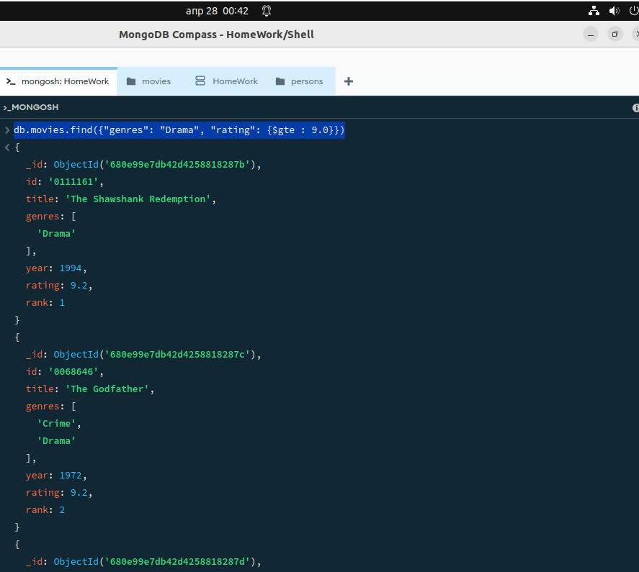

Рис.17 фильмы жанра Drama с рейтингом 9.0 и выше

1. Подсчитайте количество фильмов для каждого года выпуска.

**db.movies.agregate({$group: {_id: “$year”, count: {$sum: 1}}},{$sort:{_id: 1}}])**

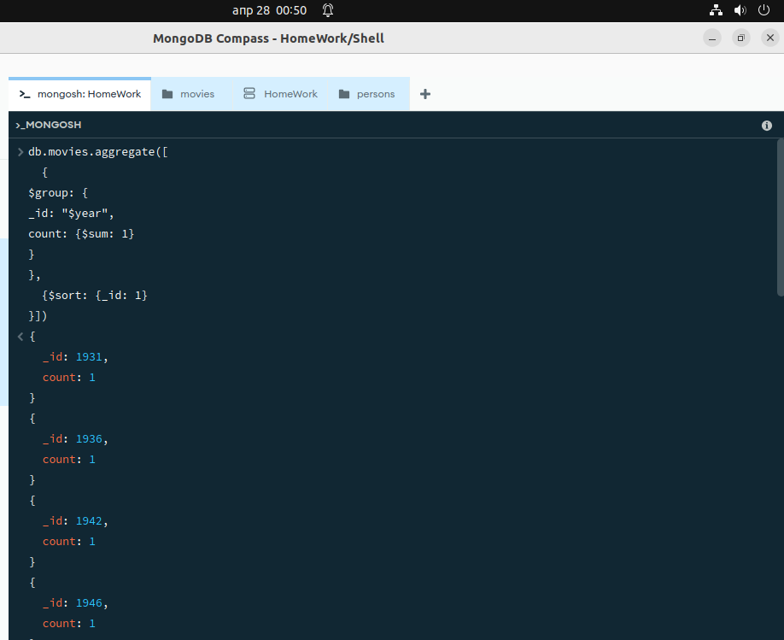

Рис.18 результат выполнения запроса

1. Увеличьте на 1000 количество голосов у фильма "The Matrix".

**db.persons.find({title:”** **The Matrix”},{“votes”: 1000})**

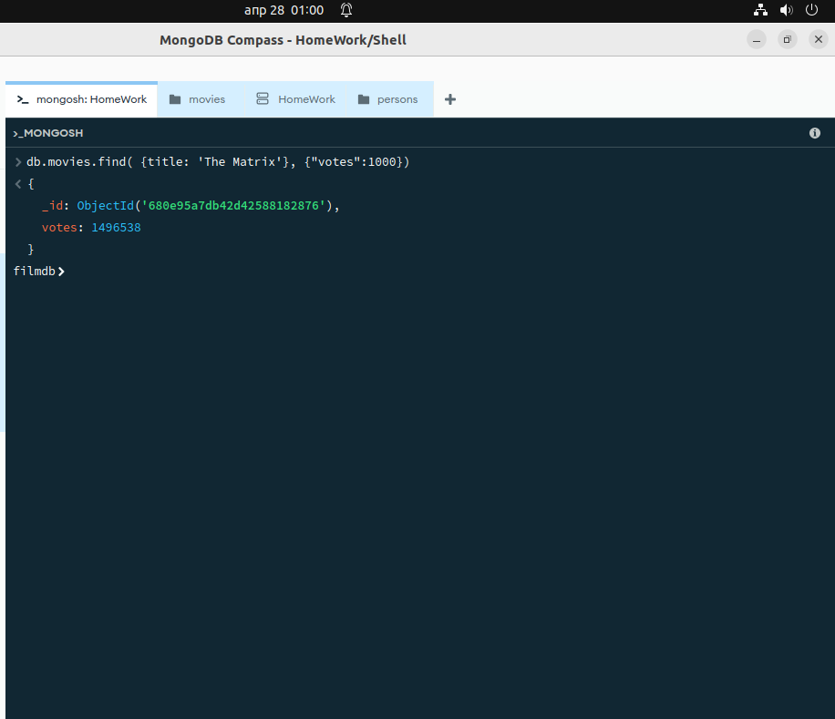

Рис.23 Результат увеличения

1. Создайте индекс по полю year.

db.movies.createIndex({ "year": 1})

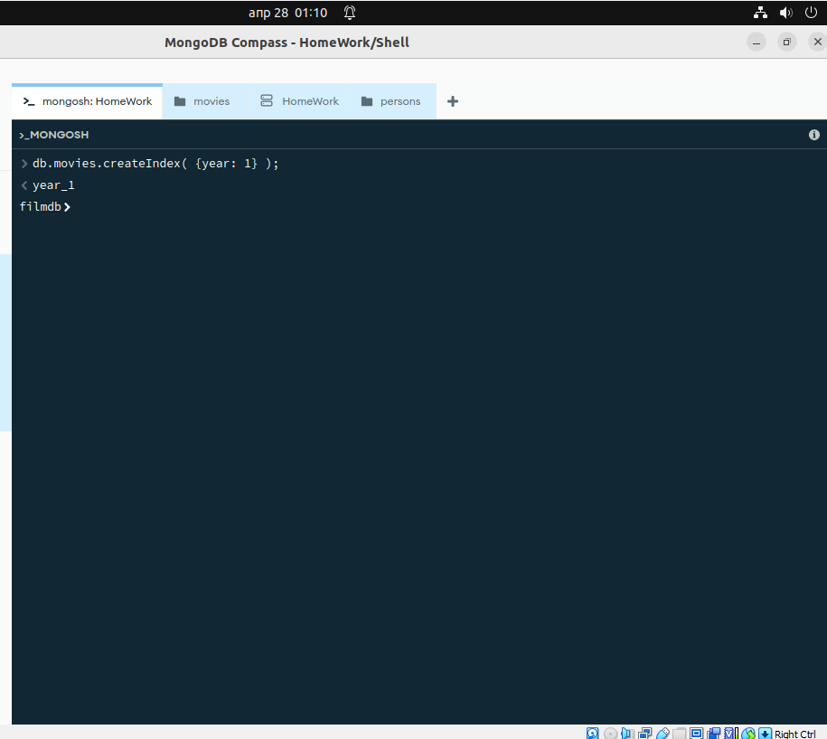

Рис.24 создание индекса

Заключение

В ходе проделанной лабораторной работы, были получены практические навыки работы с документо-ориентированной базой данных MongoDB, путем выполнения основных операций по управлению данными, а также были выполнены задания по вариантам.